 | Year 11 Earth and Environmental Science  Task 2: Rock ID Test

Name:  Due Date: | Teacher: | Score: /30

Using the rock classification key you have can you fill in the table below.

You will need to list the properties that you identify (based on the key) and then in the final column identify the name of the rock and whether it is metamorphic, igneous or sedimentary.

(16 marks) (16 marks)
Sample Number (and photo) | Properties (list) | Identification
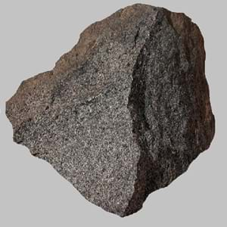

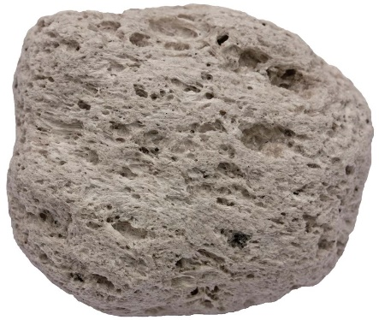

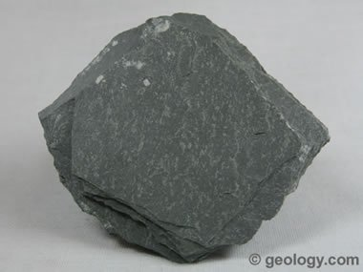

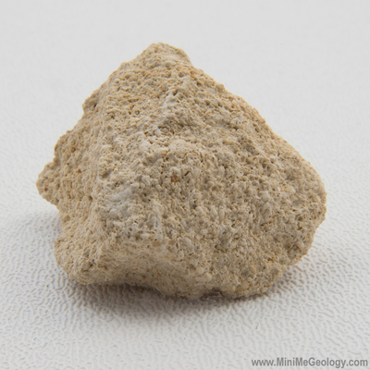
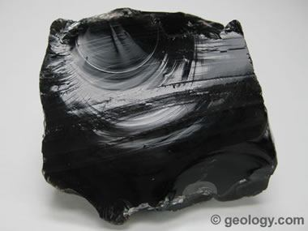
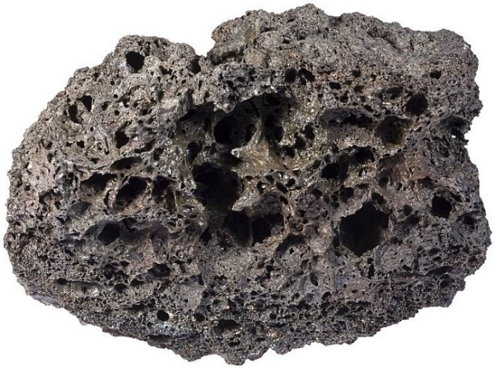

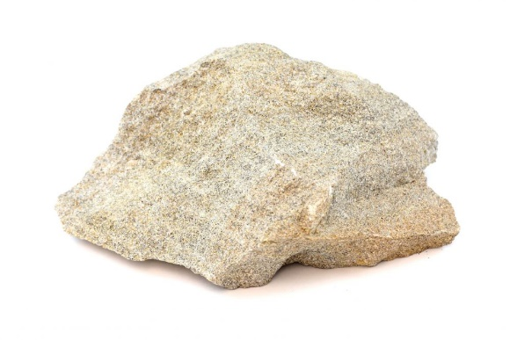
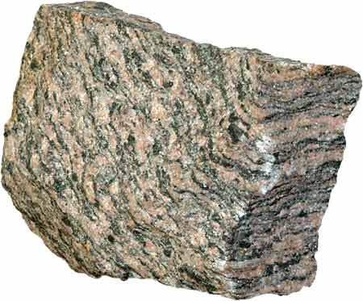

End of Assessment

